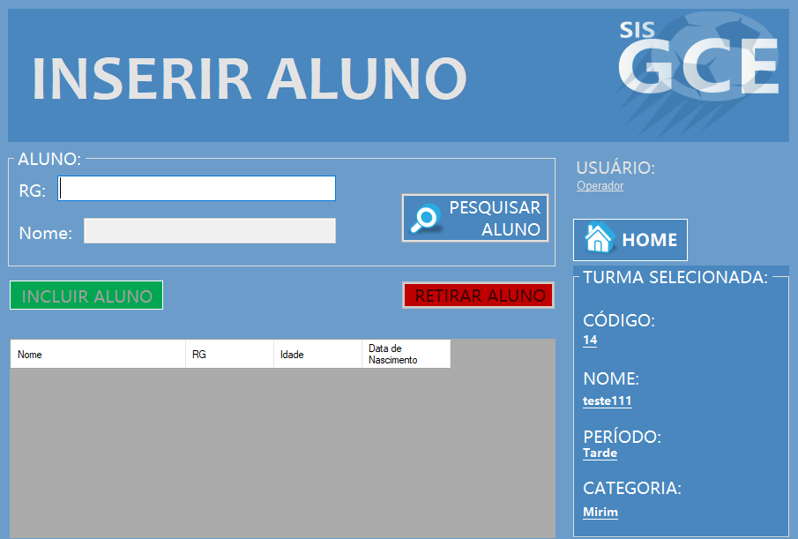

|  |  |  |  |  |
| --- | --- | --- | --- | --- |
| **CT NO.** | **PROPÓSITO** | | | |
| **01** | **VERIFICAR SE O ALUNO E ADICIONADO** | | | |
| **PRÉ-CONDIÇÕES** | | | | |
| **NÃO TEM** | | | | |
| **ENTRADA1** | | **ENTRADA2** | **ENTRADA3** | **ENTRADA4** |
| **RG** | | **NOME** | **PESQUISAR ALUNO** | * **INCLUIR ALUNO** * **RETIRAR ALUNO** |
| **SAÍDAS ESPERADAS** | | | | |
| **ALUNO INSERIDO E ALUNO RETIRADO** | | | | |

|  |  |  |  |  |  |
| --- | --- | --- | --- | --- | --- |
| **TESTE No.** | **RG** | **NOME** | **BOTAO** | **BOTAO** | **SAIDA ESPERADA** |
| **1** | **40.634.241-6** | **MAX** | **PESQUISAR** | **INCLUIR ALUNO** | **ALUNO ADICIONADO** |

|  |  |  |  |  |  |
| --- | --- | --- | --- | --- | --- |
| **TESTE No.** | **RG** | **NOME** | **BOTAO** | **BOTAO** | **SAIDA ESPERADA** |
| **2** | **40.634.241-8** | **MATHEUS** | **PESQUISAR** | **INCLUIR ALUNO** | **ALUNO ADICIONADO** |

|  |  |  |  |  |  |
| --- | --- | --- | --- | --- | --- |
| **TESTE No.** | **RG** | **NOME** | **BOTAO** | **BOTAO** | **SAIDA ESPERADA** |
| **3** |  |  | **PESQUISAR** | **INCLUIR ALUNO** | **MENSAGEM DE ERRO** |

|  |  |  |  |  |  |
| --- | --- | --- | --- | --- | --- |
| **TESTE No.** | **RG** | **NOME** | **BOTAO** | **BOTAO** | **SAIDA ESPERADA** |
| **4** |  | **VINICIUS** | **PESQUISAR** | **INCLUIR ALUNO** | **MENSAGEM DE ERRO** |

|  |  |  |  |  |  |  |
| --- | --- | --- | --- | --- | --- | --- |
| **Aplicado em** | **Aplicado**  **por** | **Quantidade**  **de falhas** | **Depurado por** | **Reaplicado**  **em** | **Reaplicado**  **por** | **Quantidade**  **de falhas** |
| **30/10/2017** | **Luiz** | **0** |  |  |  |  |